Design Patterns and Principles

Exercise 1: Implementing the Singleton Pattern

Logger.java
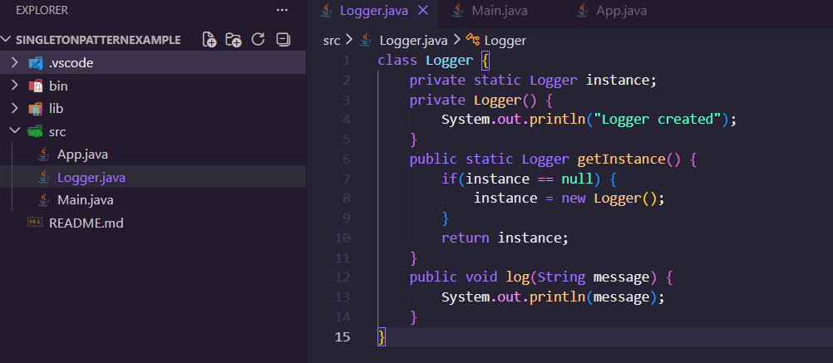
Main.java
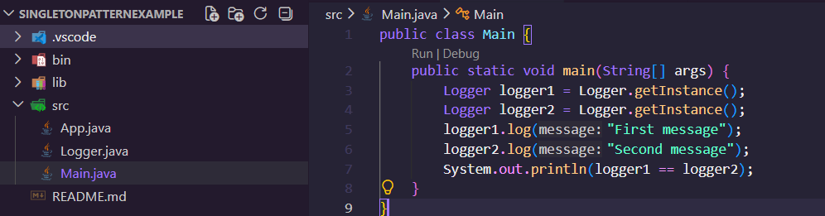

Output
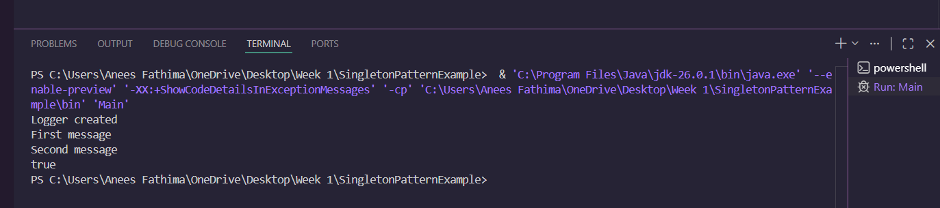

Exercise 2: Implementing the Factory Method Pattern

Document.java
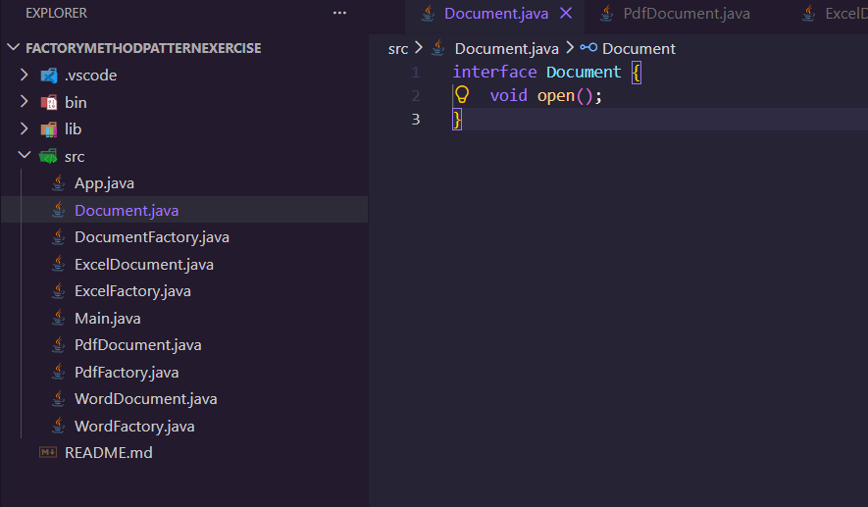

DocumentFactory.java
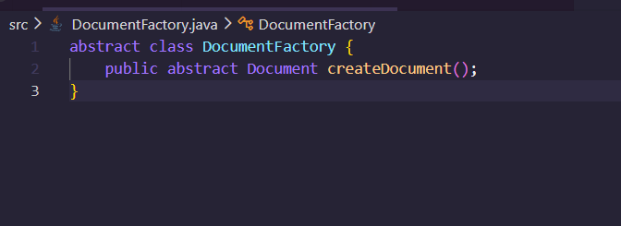

ExcelDocument.java
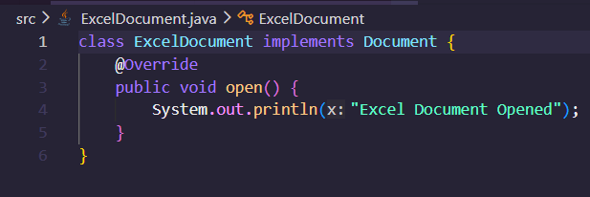

ExcelFactory.java
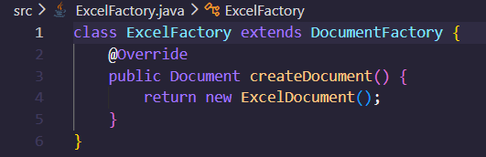

PdfDocument.java
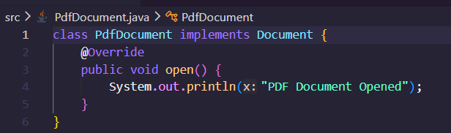

PdfFactory.java
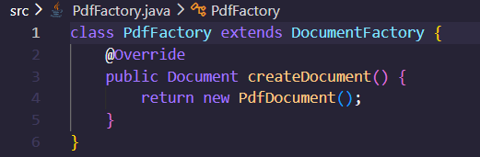

WordDocument.java
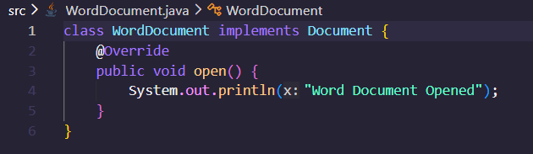

WordFactory.java
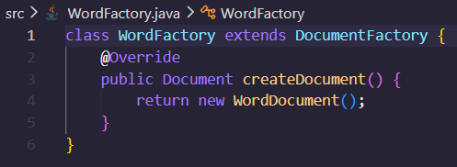

Main.java
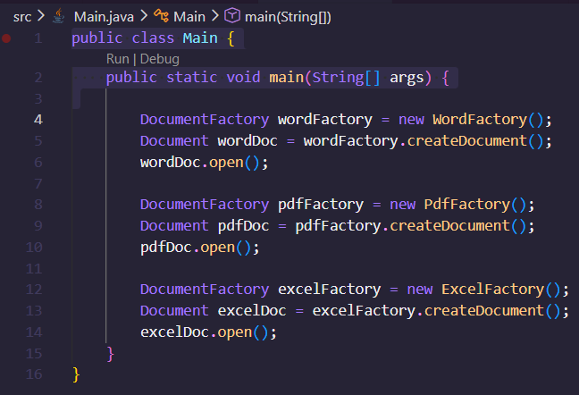

Output
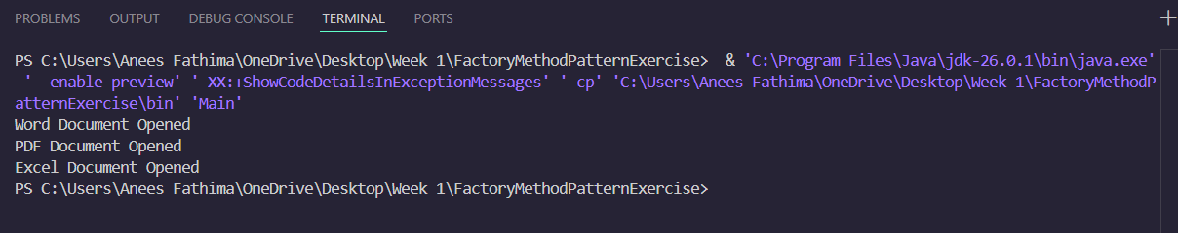

PL/SQL programming

PLSQL_Exercises

Exercise 1: Control Structures

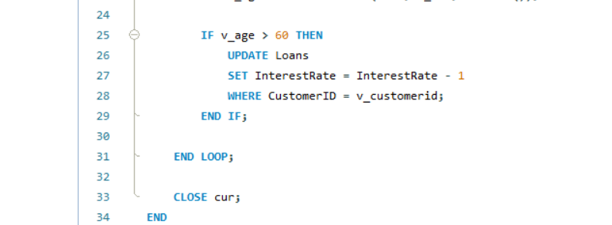
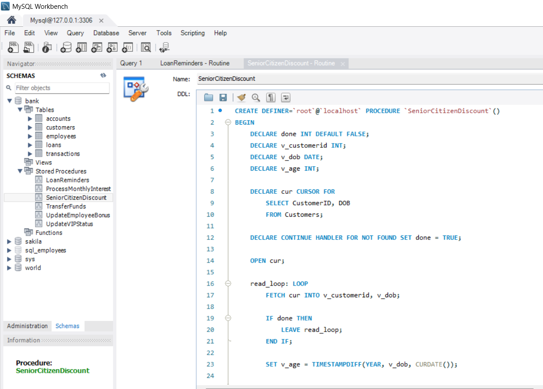
Scenario 1
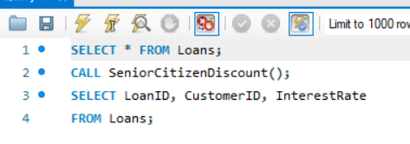

Output
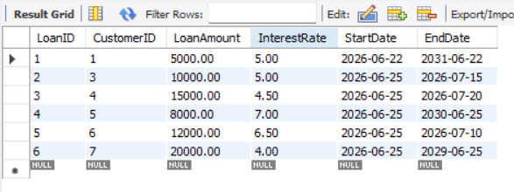
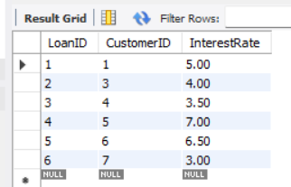

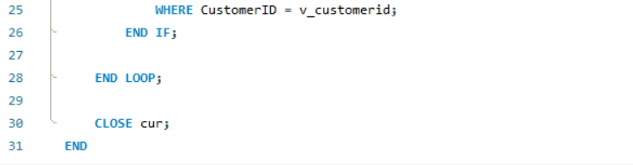
Scenario 2
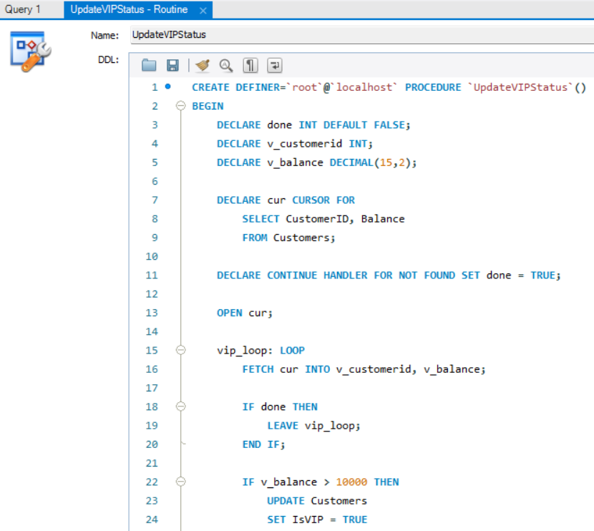
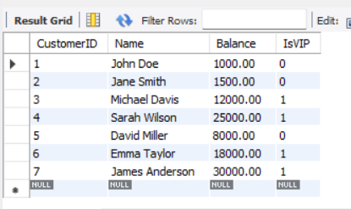
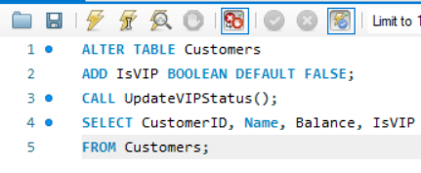
Output

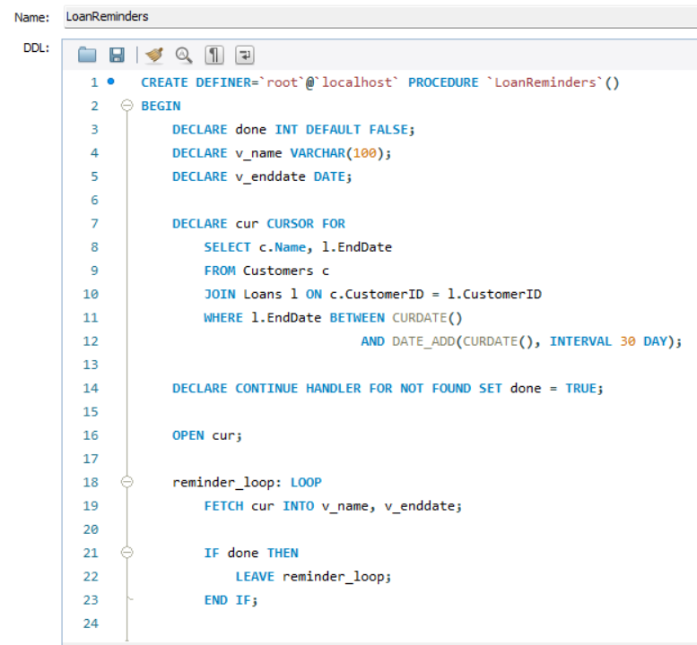
Scenario 3
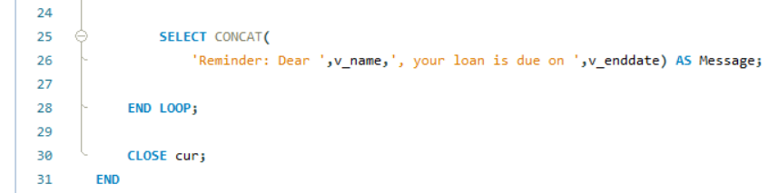

Output
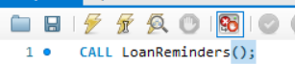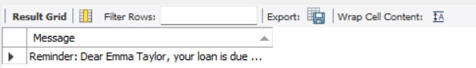

Exercise 3: Stored Procedures

Scenario 1
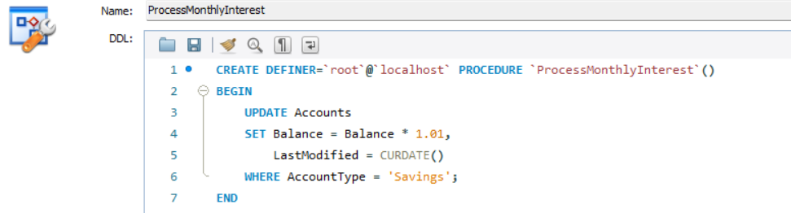
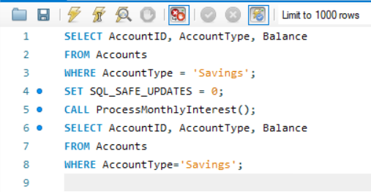
Output
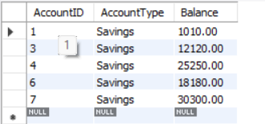
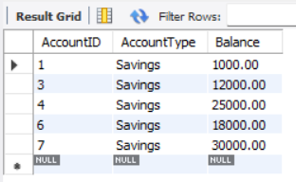
Scenario 2
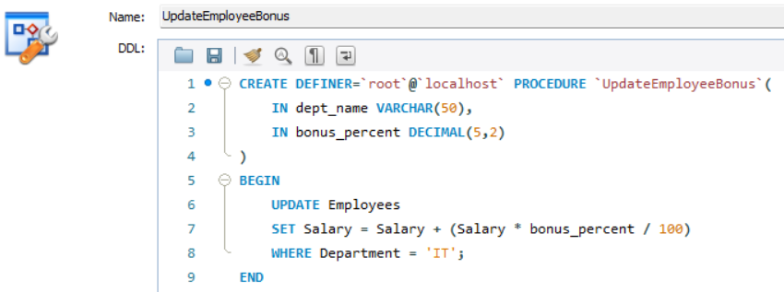
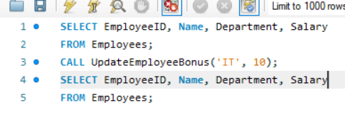
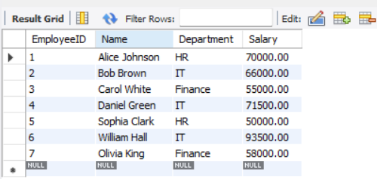
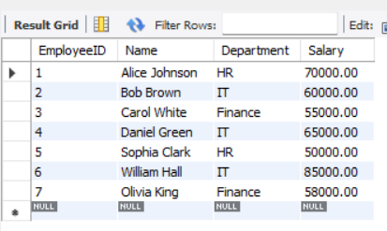
Output

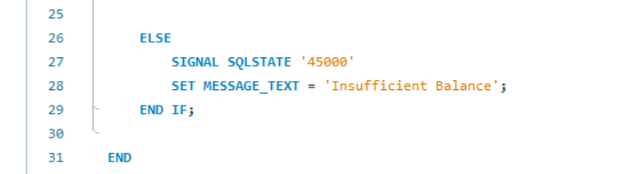
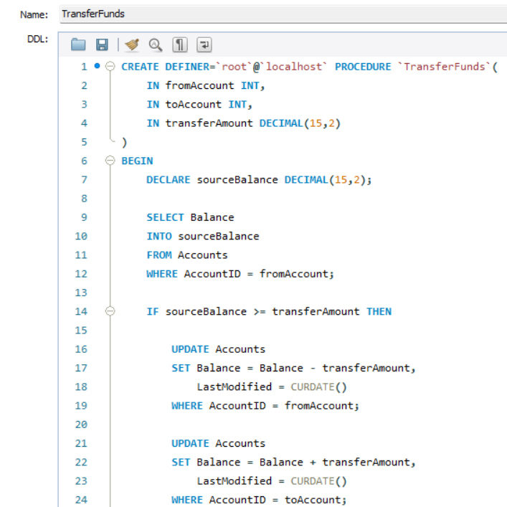
Scenario 3

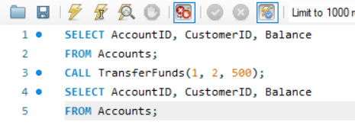
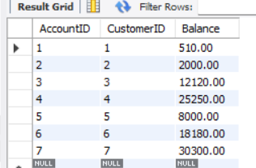
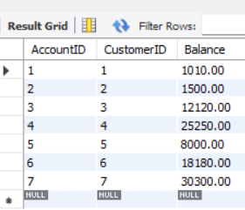
Output
Data structures and Algorithms

Algorithms_Data Structures

Exercise 2: E-commerce Platform Search Function

Big O notation is used to describe the performance or efficiency of an algorithm as the input size (n) increases.
It helps us:
- Measure execution time growth.
- Compare different algorithms.
- Predict performance for large datasets.
Search Operation Cases
Linear Search
- Best Case: O(1)
  - Element found at first position.
- Average Case: O(n)
  - Element found in the middle.
- Worst Case: O(n)
  - Element found at last position or not found.
Binary Search
- Best Case: O(1)
  - Middle element is the target.
- Average Case: O(log n)
- Worst Case: O(log n)
  - Search space repeatedly halves until the element is found or not found.

Setup
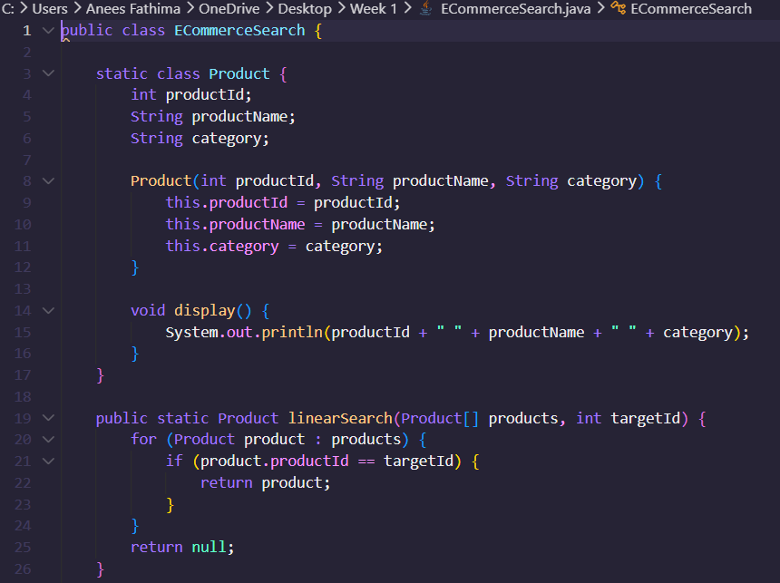

Implementation
Linear Search
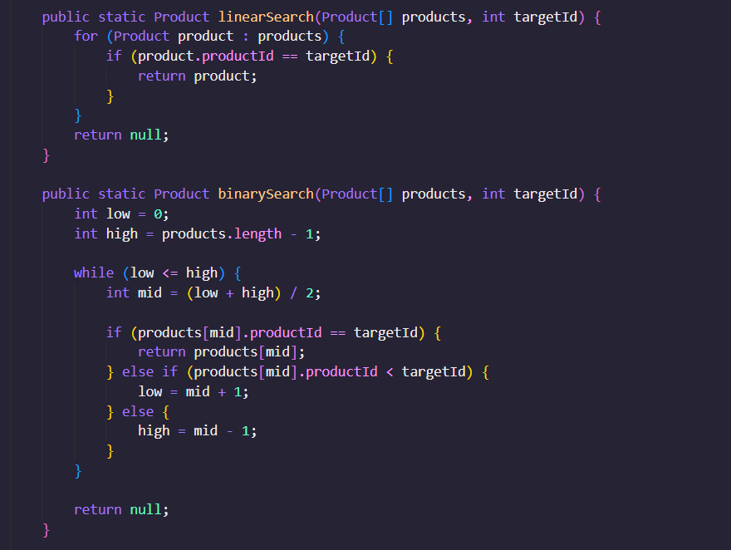

Binary Search

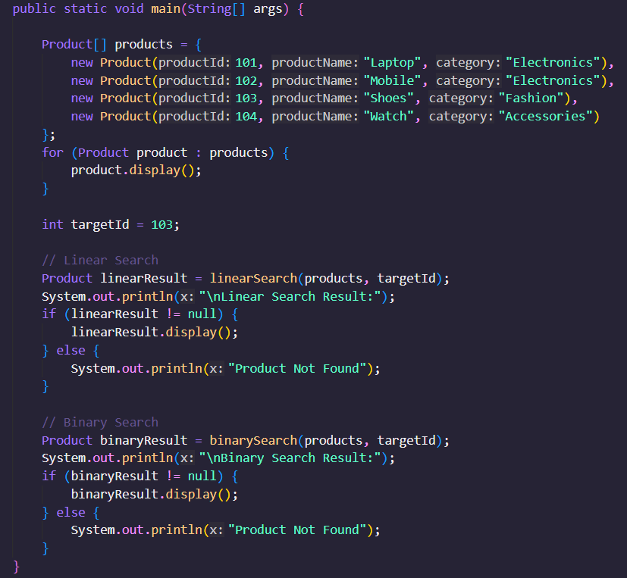

Output
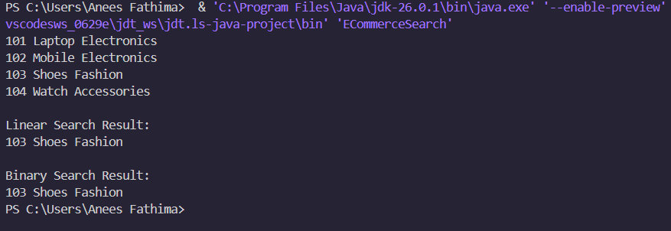

Time Complexity Comparison
Algorithm | Best Case | Average Case | Worst Case
Linear Search | O(1) | O(n) | O(n)
Binary Search | O(1) | O(log n) | O(log n)
Example
For 1,000,000 products:
- Linear Search may check up to 1,000,000 products.
- Binary Search needs only about 20 comparisons because:
$${log⁡}_{2}(1000000)≈20$$
Binary Search is More Suitable
Reasons:
- Much faster for large product catalogs.
- Time complexity is O(log n).
- Reduces search time significantly.
- Scales well as the number of products increases.
Limitation
Binary Search requires the products to be sorted by productId.

Exercise 7: Financial Forecasting

Recursion is a programming technique where a method calls itself to solve a smaller version of the same problem until a base case is reached.
Benefits of Recursion
- Makes code simpler and easier to understand for some problems.
- Useful for mathematical calculations, tree traversals, and forecasting models.
- Breaks a large problem into smaller subproblems.

Setup
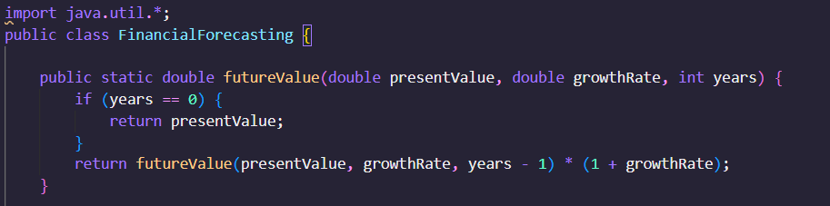

Implementation
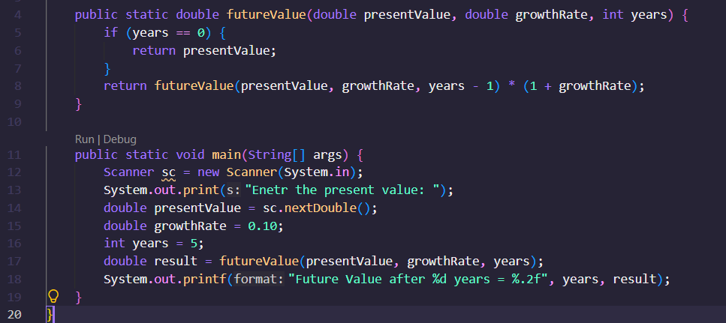

Output
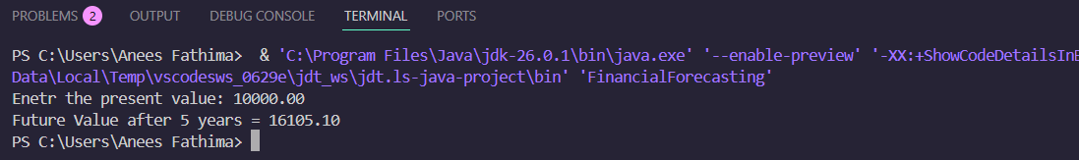

Analysis
Time Complexity
For each recursive call, the value of years decreases by 1.
T(n) = T(n-1) + O(1)
Therefore:
Time Complexity = O(n)
where n is the number of years.
Space Complexity
Each recursive call is stored on the call stack.
Space Complexity = O(n)
Optimization
The recursive solution creates n stack frames.
For very large values of n, recursion may:
- Consume more memory.
- Cause stack overflow.
Iterative Optimization
double futureValue = presentValue;
for(int i = 1; i <= years; i++) {
futureValue *= (1 + growthRate);
}
Complexities:
Time Complexity = O(n)
Space Complexity = O(1)

TDD using JUnit5 and Mockito

1. JUnit_Basic Testing Exercises

Exercise 1: Setting Up JUnit

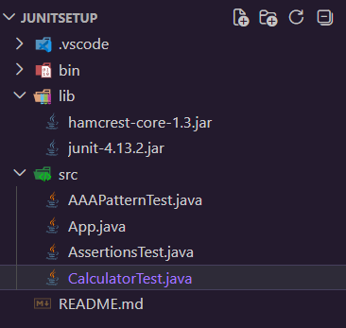

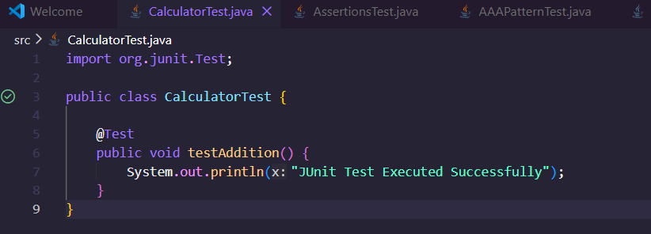

Output
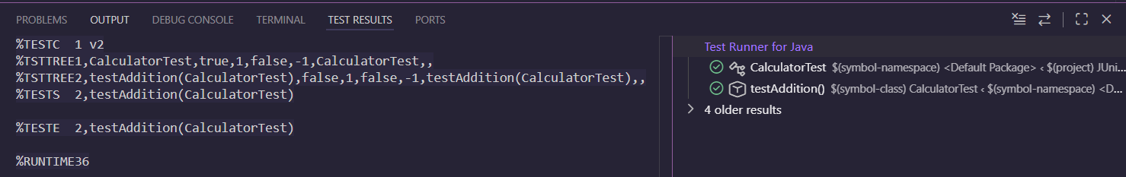
Exercise 3: Assertions in JUnit

AssertionsTest.java
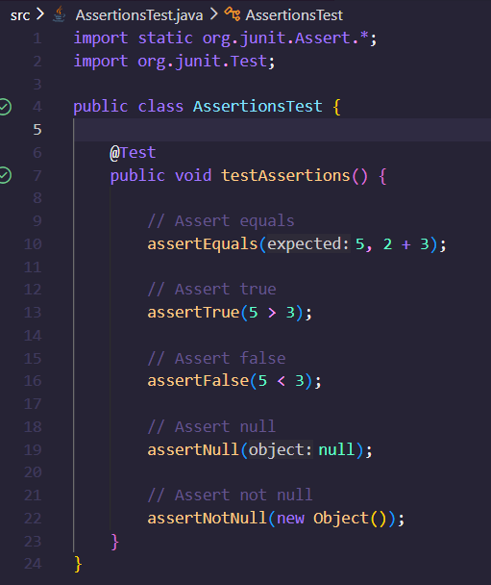

Output
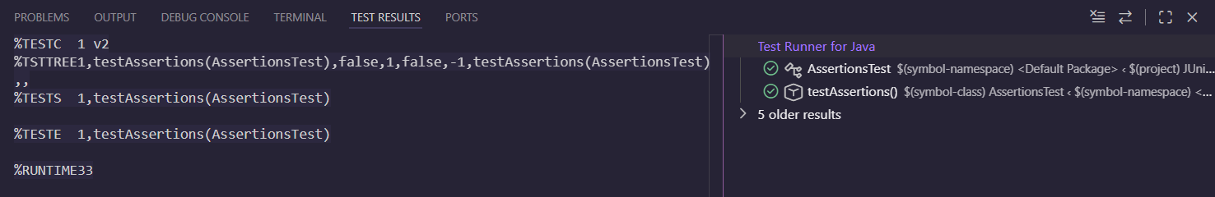

Exercise 4: Arrange-Act-Assert (AAA) Pattern, Test Fixtures, Setup and Teardown Methods in JUnit

AAAPatternTest.java

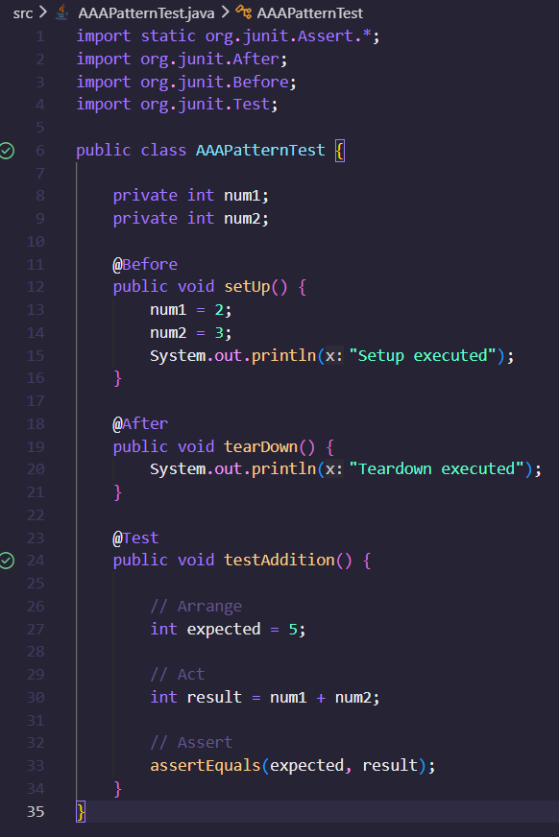

Output
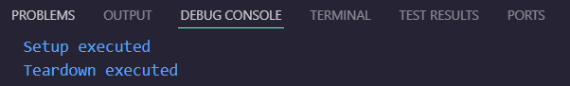
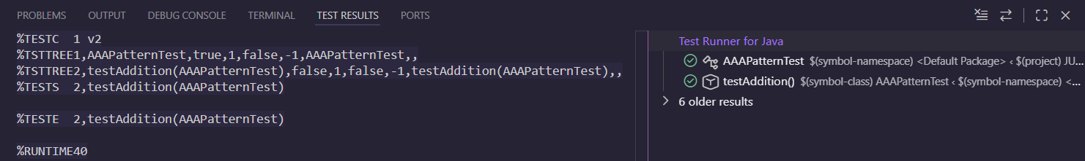
3. Mockito exercises

Exercise 1: Mocking and Stubbing

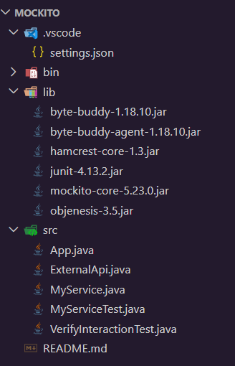

ExternalApi.java
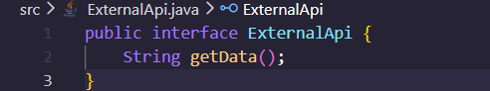

MyService.java
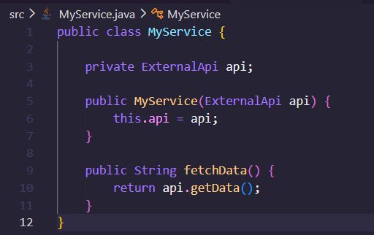
MyServiceTest.java
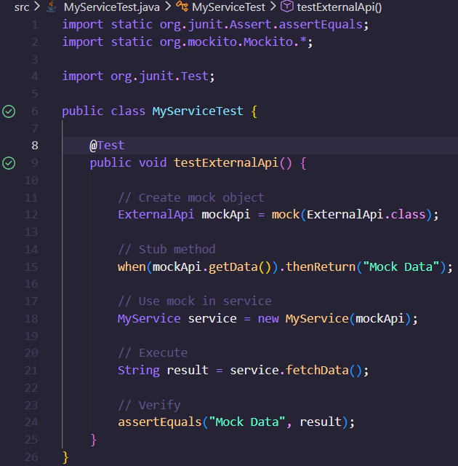

Output
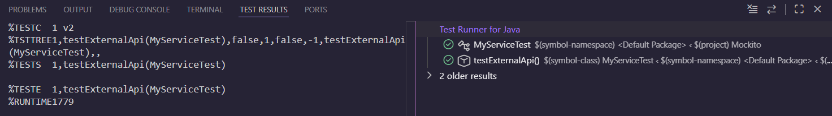

Exercise 2: Verifying Interactions

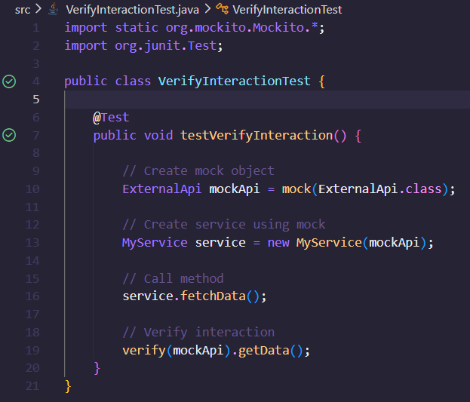

Output
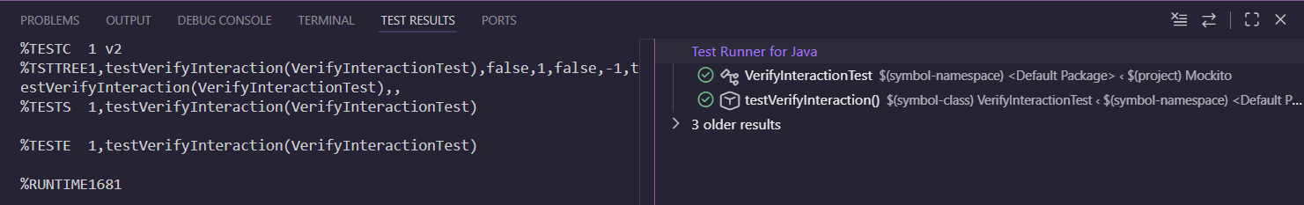

6. SL4J Logging exercises
Exercise 1: Logging Error Messages and Warning Levels

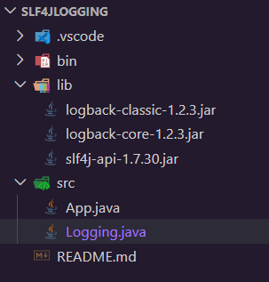

Logging.java
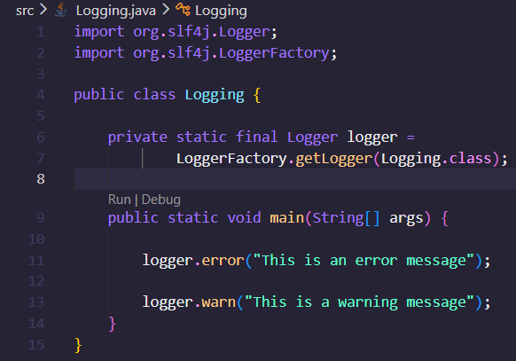

Output
